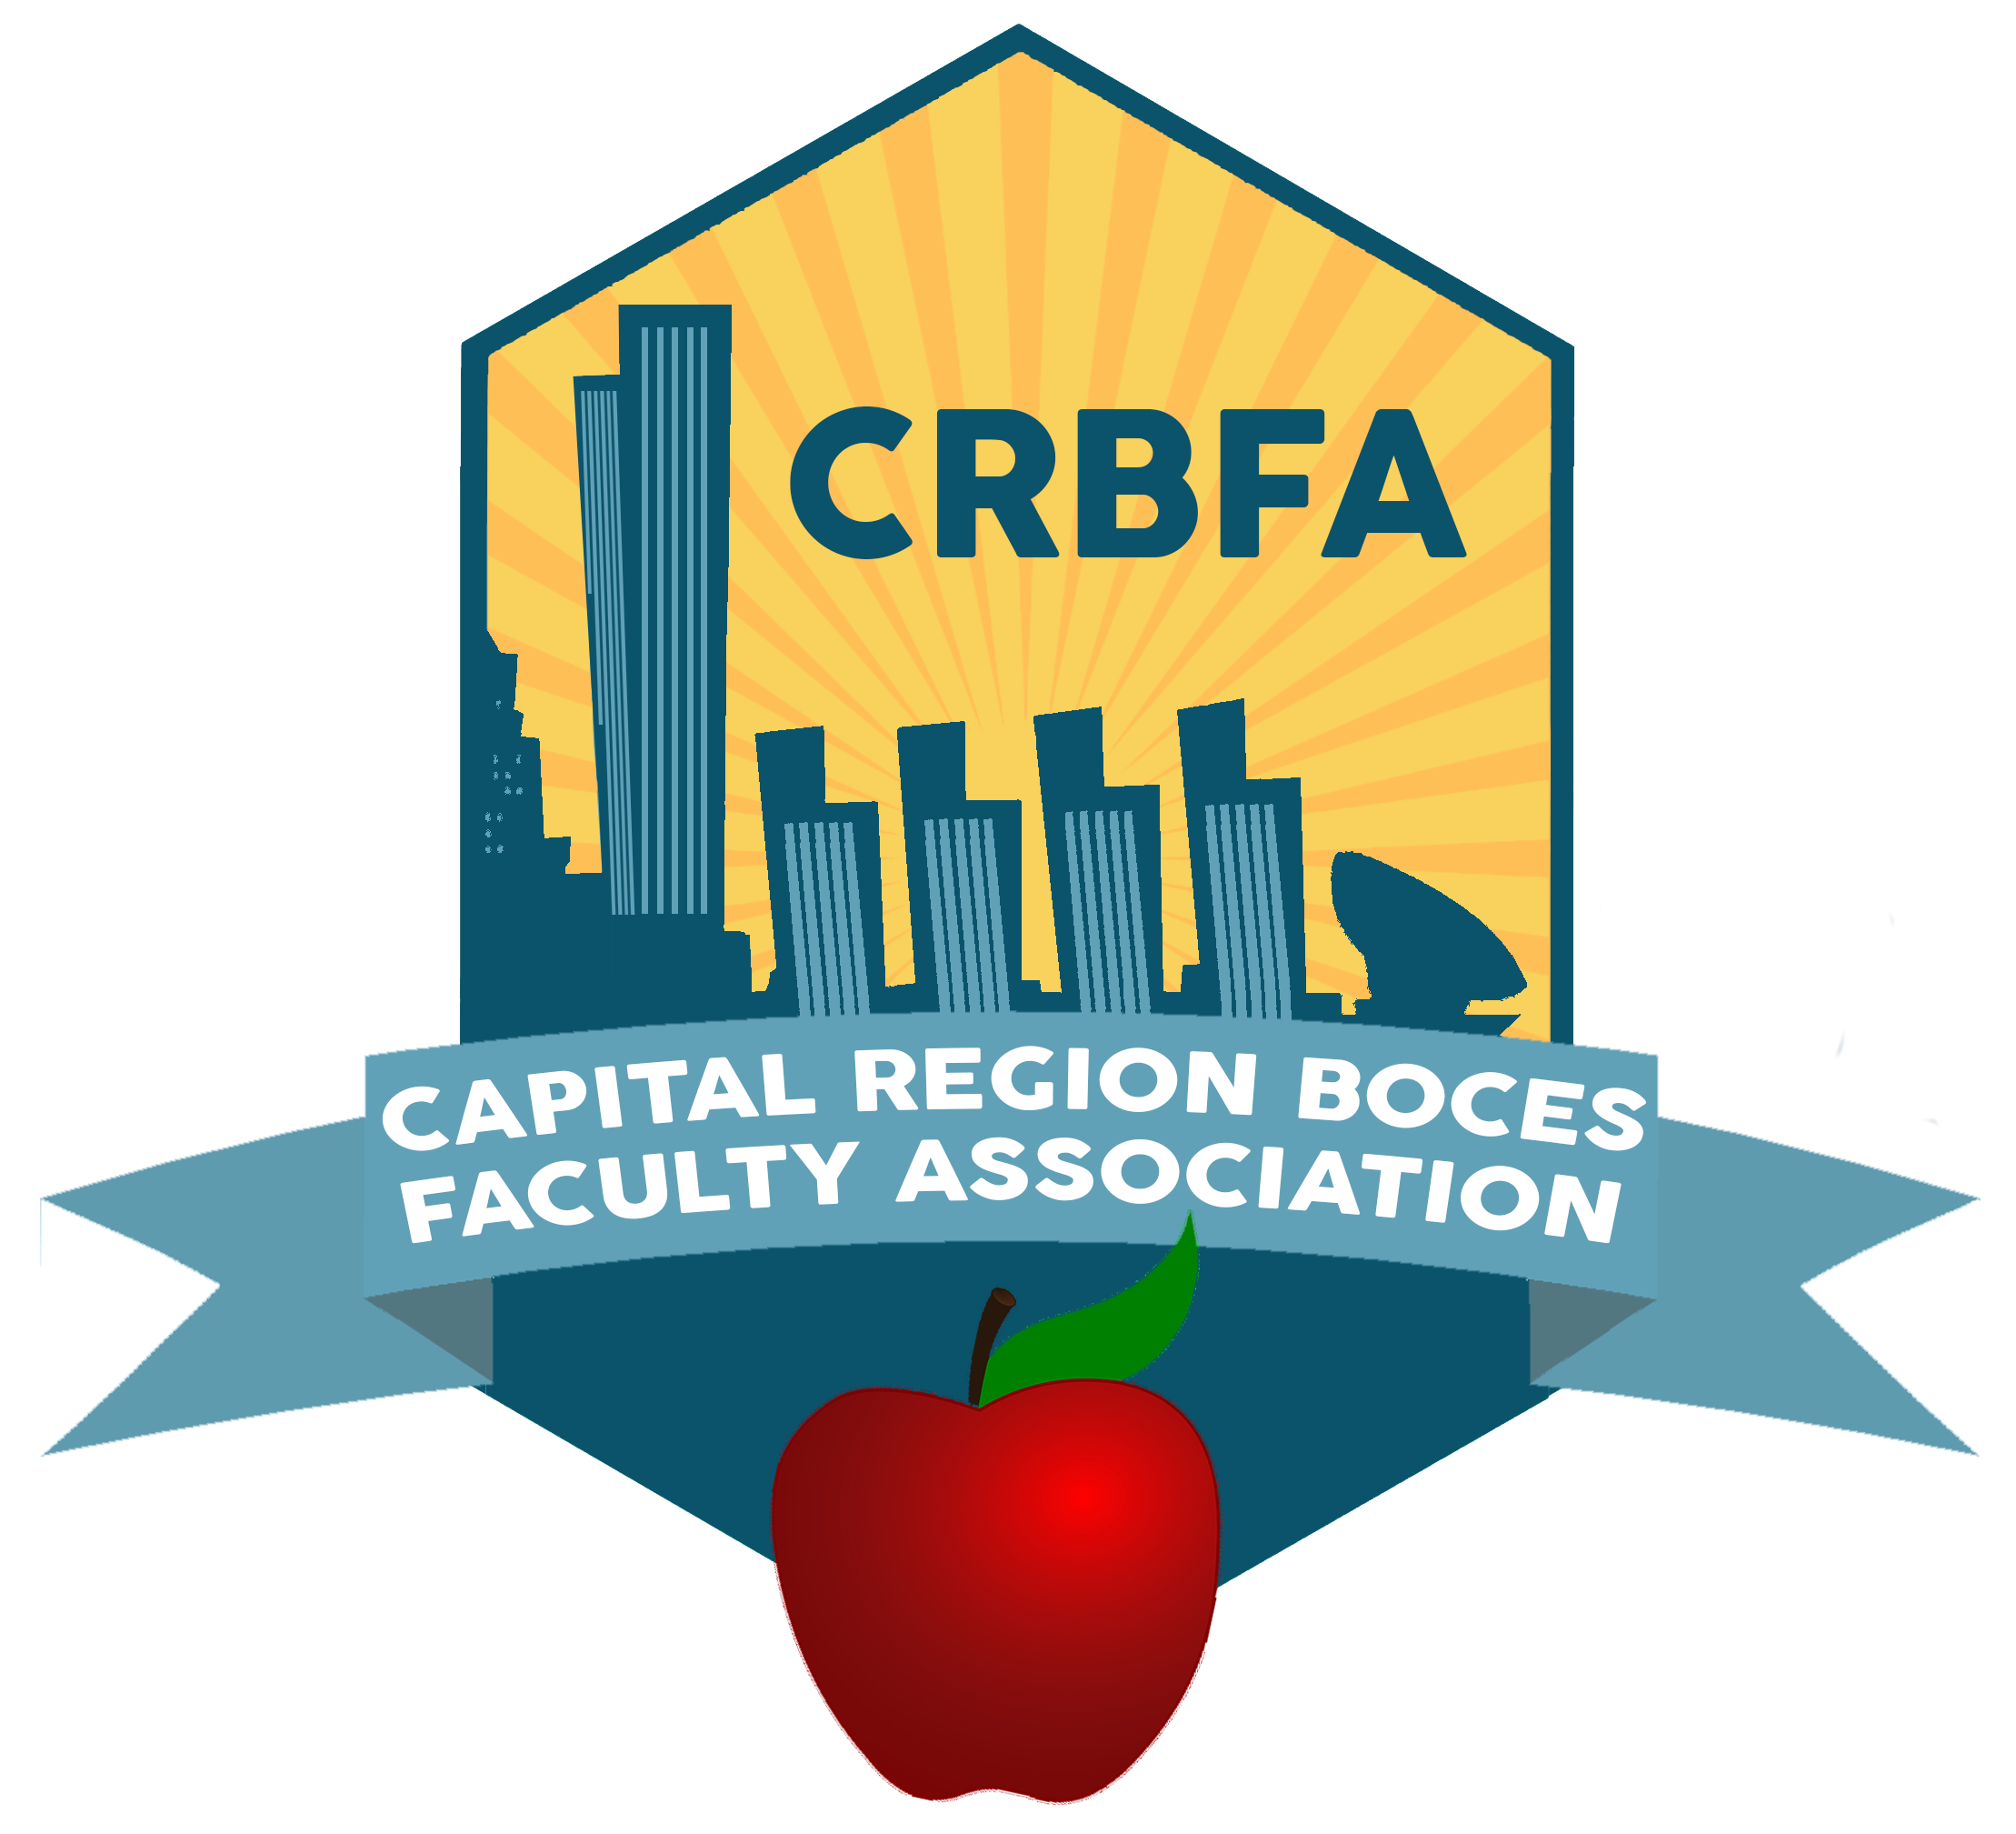
Student Incentive Award
2025-26 School Year
___________

One $1,000 award

One for a child of a member intending to further their education in a trade school or college

TO BE COMPLETED BY STUDENT AND GUARDIAN (please print):

Student name ___________________________________________________________ Date of birth __/__/__
Permanent address ___________________________________________________________________________
Student email ______________________________ Parent/Guardian email: ______________________________
Parent/Guardian (Association member) ____________________________ Occupation ____________________
College or training program you plan to attend _______________________________________________________
Years of study required _______ Major field of study ____________________________________________
Have you been accepted? ________________________

List school and community activities below:
Activity / Responsibility to Organization / Years of Involvement

___________________________________________________________________
___________________________________________________________________
___________________________________________________________________
___________________________________________________________________ ___________________________________________________________________

List any work experience:

Place of Employment / Job Responsibility / Date of Employment / Hours per Week

__________________________________________________________________________________
__________________________________________________________________________________
__________________________________________________________________________________

IMPORTANT:

In a separate document, type a statement with approximately 200 words describing your goals in this field, your plans for the future and how your work and community experiences have helped you shape these goals.

Student Incentive Form Instructions:
- Fill in all information.
- A transcript of student grades should be included with this application.
- Application, statement, transcript, and any other pertinent information should be emailed to:
CRBFacultyAssociation@gmail.com

Application, Statement, and Transcript due Monday, April 6th 2026

Any questions, please contact CRBFacultyAssociation@gmail.com

